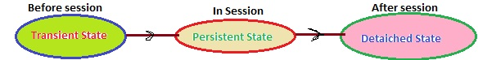

1. Transient State:
A New instance of a persistent class which is not associated with a Session, has no representation in the database and no identifier value is considered transient by Hibernate:
- UserDetail user = new UserDetail();
- user.setUserName("Dinesh Rajput");
- // user is in a transient state

2. Persistent State:
A persistent instance has a representation in the database , an identifier value and is associated with a Session. You can make a transient instance persistent by associating it with a Session:
- Long id = (Long) session.save(user);
- // user is now in a persistent state

3. Detached State:
Now, if we close the Hibernate Session, the persistent instance will become a detached instance: it isn't attached to aSession anymore (but can still be modified and reattached to a new Session later though).
- session.close();
- //user in detached state

